|  |  |
| --- | --- |
|  | |
|  | |
| Concept Selection Report  Group 13 | |
| **Module code:** | **EG2005** |
| **Module name:** | **Engineering Design 2** |
|  | |
| 01/12/2016 | |
|  | |
| **Author(s):** | **Paul Longe, Divine Abraham, Alexandros Agrafiotis, Bradley Blocksidge, Keqi Shu, Xiang Zhang** |
| **Student ID(s):** | **[Number]** |
| **Managers:** | **Tom Gibbs, Sameera S. Fernando** |
| **Degree:** |  |
| **Tutor/Project supervisor:** | **[Name]** |
|  | |

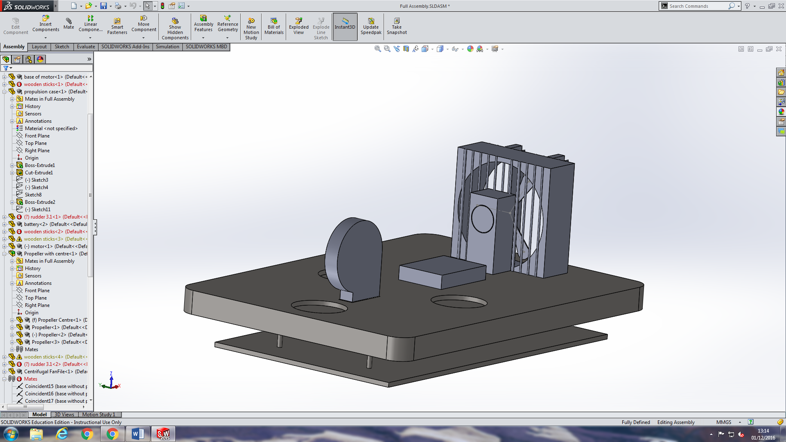

Contents

1 Introduction – Paul Longe 1

List of members and Responsibilities 1

1.1 Chassis Engineer – Bradley Blocksidge 1

1.2 Design Engineer - Alexandros Agrafiotis 1

1.3 Powertrain Engineer – Keqi Shu 2

1.4 Integration Engineer – Paul Longe 2

1.5 Electrical Engineer – Divine Abraham 2

1.6 Payload Specialist – Xiang Zhang 2

2 Design Criteria – Bradley Blocksidge 2

3 Requirement Tree – Divine Abraham 0

4 Morphological Diagram – Keqi Shu 0

5 Initial Concepts – Individual task 1

5.1 Chassis Design- Bradley Blocksidge 1

5.2 Materials and Fan selection- Alexandros Agrafiotis 2

5.3 Battery study and motor selection – Keqi Shu 2

5.4 Turning Mechanism - Paul Longe 3

5.5 Electrical Systems – Divine Abraham 4

5.6 Payload – Xiang Zhang 5

6 Synthesis chart 0

7 Materials & Pricing - Alexandros Agrafiotis 0

8 Conclusion on design After VDP2 – Xiang Zhang 1

8.1 Chassis – Bradley Blocksidge 1

8.2 Fans and Materials selection - Alexandros Agrafiotis 1

8.3 Powertrain system – Keqi Shu 2

8.4 Turning Mechanism – Paul Longe 3

8.5 Electrical Control – Divine Abraham 4

8.6 Payload - Xiang Zhang 4

9 Appendix 5

# Introduction – Paul Longe

The design task is to design and build a working prototype of a hovercraft as specified in the EG2005 task document, the hovercraft has set maximum dimensions and minimum weight carrying capacity so that it can be used as a model for real world situations. The design quality will be assessed through the following criteria:

1. The vehicle should be able to start/stop as required
2. The hovercraft should be able to move freely over small obstacles of height less than 5 millimetres.
3. The highest Payload Lift Capacity
4. The highest score of payload mass times distance travelled
5. The lowest overall project cost
6. The design process quality assessed by a Panel of VDPs

The hovercraft will travel in a course of dimensions 4.4mx1.2m, and travel over obstacles of a height under 5mm, there is an area with no obstacles where the hovercraft can turn. More points are scored for the amount of laps made and the load carried. 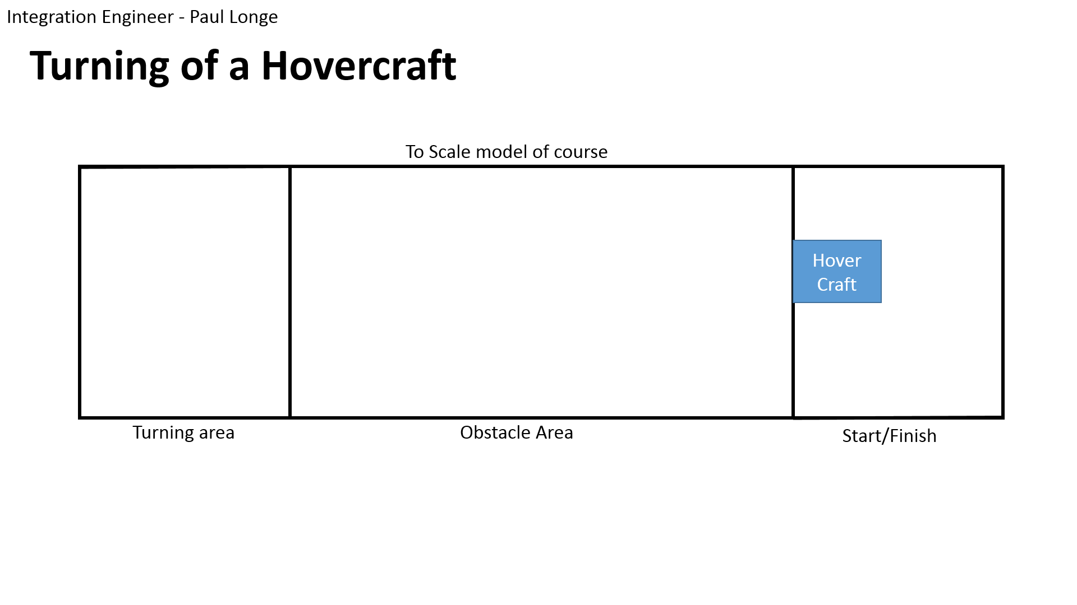

The hovercraft flies on a cushion of air, generated by a lift fan that moves the air at a low speed but high pressure. Because the hovercraft moves on this cushion of air, it experiences very little friction, and is capable as a multi-terrain vehicle. As the friction is small, very little power is required from the thrust fan, so it is also more fuel-efficient then a boat. This makes them extremely suitable for rescue missions, as an amphibious vehicle the hovercraft can operate on: mud flats, sand banks, frozen seas, around shores, and many other places that a boat or car are not able to reach. The hovercraft needs to be able to carry a load which can be people, or medicinal equipment in a rescue situation. This is why the prototype similarly has a minimum load it must be capable of carrying.

## List of members and Responsibilities

## Chassis Engineer – Bradley Blocksidge

The chassis of the hovercraft is the main body of the craft. This chassis will have to hold everything for the hovercraft and still be able to lift and overcome obstacles. With the skirt deflated, the hovercraft has to be smaller than 420 x 297mm in size. The skirt of the craft will need to have enough pressure and lift to allow obstacles of 3mm in height to pass under the whole hovercraft and for it to continue on its way.

## Design Engineer - Alexandros Agrafiotis

A design engineer has to to deal with fans, materials and budget. We decided to go with a centrifugal fan for the lift because it produces high pressure in low power. An axial fan is going to be used for thrust. Basic material is going to be the Craft Foam Blue because it is light, strong for our application, easy to change the shape and the price was more than good for the budget we have. The total cost of materials and components is going to be around £184.15. Moreover, safety covers will be made to protect us from the rotating blades and a cover around it so we can prevent any accident.

## Powertrain Engineer – Keqi Shu

The powertrain engineer is responsible for the power system which include power supply, power safety, power transmission. The powertrain engineer should design the circuit that is safe and efficient and most importantly, that would work. It should also be responsible for the motor selection including the force motion motor and the servo motor. What’s more, the powertrain engineer should take in charge for the power transmitting structure and make sure that the battery can supply enough energy.

## Integration Engineer – Paul Longe

The Integration Engineer is responsible for ensuring that each member of team works together to form a cohesive solution to the problem. The Integration Engineer also had the additional role of designing the mechanical components of control of the hovercraft; with the main priority to ensure that the hovercraft is capable of performing a 180° turn within the 1x1.2m area.

## Electrical Engineer – Divine Abraham

The electrical and control systems engineer is responsible for the design and implementation of the electrical and control systems. Its also the responsibility of the electrical engineer to work closely with the powertrain engineer to deliver a system that is capable of starting and stopping, using a standard radio control system. The system would get enough lift and be capable of overcoming small obstacles and shall travel at a minimum speed of 1.4 m/s.

## Payload Specialist – Xiang Zhang

The Payload Engineer in the group is responsible for design, the appearance of the payload, and for the arrangement and position of each component on the hovercraft, such as fans and load area. At the same time, payload engineer needs to adjust the location of components to help the hovercraft keep balance. Balance is the precondition for running the hovercraft.

# Design Criteria – Bradley Blocksidge

The project that we have been given is to build and design a model hovercraft that will be able to carry a load and complete a course. However, with this, a specification is given for the hovercraft consisting of how it must perform and restrictions on the hovercrafts build. The hovercraft parts have to be purchased from the departmental stores of the university or from their preferential suppliers. The list of these suppliers and the prices of materials are found on blackboard in the specification document under Annex lll.

The dimensions of the hovercraft are restricted to being 420 x 297mm in size with the hovercraft skirt deflated. There is no restriction in the height of the hovercraft or the weight so we can simply make these decisions. The hovercraft must carry a discrete number of payload masses of 200g. This/these masses must be secured safely within a loading area during transportation.

The hovercraft will be controlled by a standard radio control system provided by the university. A battery provided by the university will also power the hovercraft. From this battery, the hovercraft must be able to travel in a straight-line speed of 1.4m/s. using the controller the hovercraft must be able to start and stop.

Finally the completed hovercraft needs to be safe to use. Any propellers/impellers used on the craft have to be enclosed by cowling that is 20mm in front and behind of the plane of the blade. Also the payload masses must be held securely when the craft is moving. This can be done in a range of ways but the option used must be safe.

# Requirement Tree – Divine Abraham

Be able to lift off the ground

Change direction

Travel at a minimum speed

Fully Functional Hovercraft

Dimensions

Payload

Materials and manufacture

Safety

Have a payload area

Carry a minimum payload mass of 200g

Carry multiple payloads

Secure payload for restricted movement

Maximum length of 420 mm

Maximum width of 297 mm

Must be enclosed in cowling extending a minimum of 20 mm in front and 20 mm behind the plane of the propeller.

The flexible skirt, propeller, mechanical fixtures and drive components-purchased from university’ preferential suppliers

Control & Propulsion

50%

50%

30%

30%

40%

100%

100%

30%

15%

20%

30%

1.1

1

1.2

1.3

1.4

2.1

2

2.2

2.3

3

4

5

3.1

3.2

4.1

5.1

20%

20%

20%

20%

# Morphological Diagram – Keqi Shu

../Desktop/finally.pdf

Image of turning craft found online

# Initial Concepts – Individual task

## Chassis Design- Bradley Blocksidge

Initial concept ideas for the chassis and skirt for the hovercraft were very basic and need lots of further research. The main body of the chassis had 3 many shapes, a circle, rectangle and tear drop shape are the main 3. There is no big difference or benefits from picking any of the shapes. The amount of drag from the shape of the hovercraft will be the same for all the shapes. This doesn’t really need to be considered when picking a shape. At first thoughts, the rectangle shape seems best, as this would be the easiest shape to attach a skirt.

**4.11 4.12 4.13**

Beneath the shaped top layer there could possibly be a reinforcement layer. This reinforcement layer would be there to stop the hovercraft bending or bowing. As the craft is quite large, this layer from the start was going to be necessary to ensure the hovercraft stayed stable. **(4.2)**

The skirt design was the first thing to consider. Ensuring that the skirt has enough pressure and gives enough lift is the most important thing about the hovercraft. The three types of skirt that are primarily used are finer, wall and bag skirts. Finger skirts are by far the best skirt to use but they take much more time and difficulty to make. Initially a wall skirt design was the idea that I was going for, this design would be very easy to make and use very littles amounts of material too. However because the hovercraft has to go over obstacles this design my not work as lots of air will leak with a wall design for the skirt.

Finger Wall

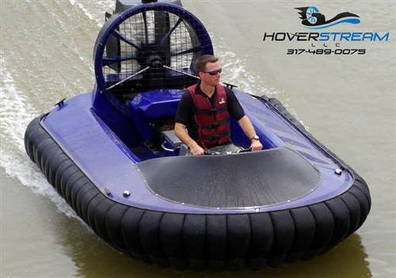 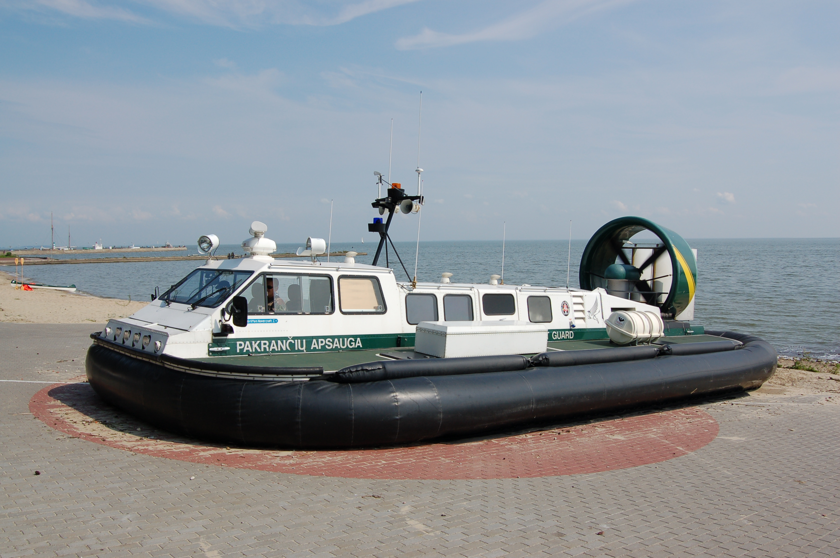

**4.31 4.32**

Finally, a momentum curtain is an option for us when creating a hovercraft. The momentum curtain could attach with four pins to the reinforcement layer. This momentum curtain tunnels the air from the fan to the edges of the skirt. By doing this, the velocity of the air increases so the pressure within the skirt increases. By increasing the pressure under the hovercraft it have more lift and will be more likely to overcome obstacles. Adding the momentum curtain to the hovercraft would not be a difficult venture and should not be too heavy, and from doing this, you could drastically increase the likelihood of the hovercraft being successful.  **(4.4)**

Below is the main drawing from my first VDP meeting. This drawing is side on and clearly shows the wall skirt and the three main layers of the hovercraft chassis. This drawing initially is a good basis for the hovercraft and can be explained and specified for the VDP 2 meeting.

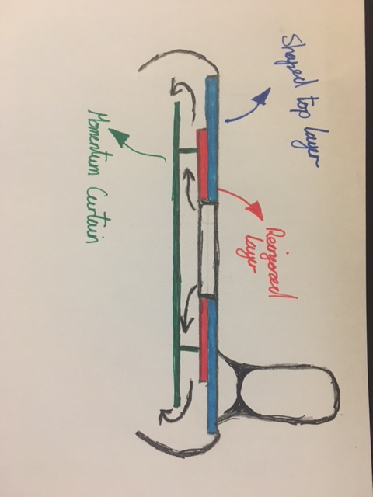*All bold numbers reference the synthesis chart.*

## Materials and Fan selection- Alexandros Agrafiotis

|  |  |  |  |  |  |  |  |  |
| --- | --- | --- | --- | --- | --- | --- | --- | --- |
| VDP 1 | | | |  | VDP 2 | | | |
| Fan type | **Feature** | **Properties** | **Material** | **Fan Type** | **Feature** | **Properties** | **Material** |
| First type 6.1 | 3 short blades | Plastic | Craft Foam Blue | Centrifugal Fan | Produces high pressure in low power | Plastic | Craft Foam Blue |
| Second type 6.2 | 2 long blades | Carbon |
| Third type 6.3 | 2 long blades with curves | Plastic |

**Numbers in bold reference to synthesis chart**

## Battery study and motor selection – Keqi Shu

I look through the basic character of the battery from the Datasheets that first of all it is a rechargeable battery, and it has a nominal voltage of 11.1V and a nominal capacity of 2600mh, which gives me a primary range of values of characters for the motors that I could choose. As I go through more detailed search for purchasing I found out that lots of motors are 12V which fitted our battery perfectly. Also the energy of the battery is 28.8Wh. So if we want the craft to work for an hour, it can provide a power of 28.8W (adding up all the powers of motors) which is quite enough.

Then from the knowledge I got from the earlier studies, I selected the motor that are cheap, light, efficient and stabled. The graph below shows the options I have. In the end I decided to choose the servo motor for the motion motor because it’s affordable and more accurate, and brushed motor for the load motor because it’s really cheap and has a steady and strong rotation speed.

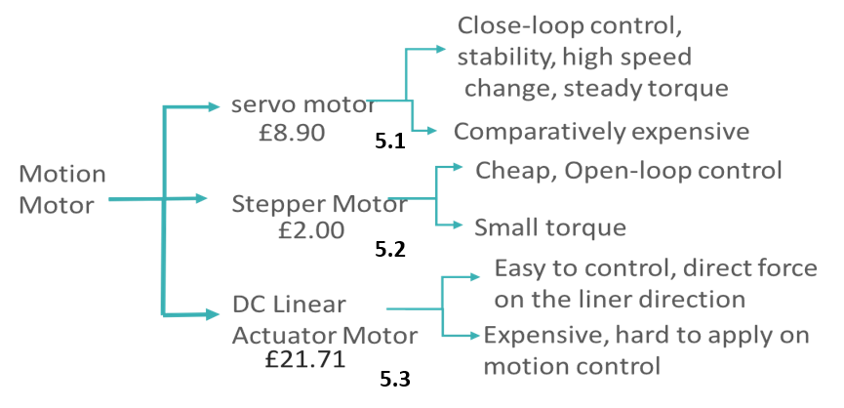

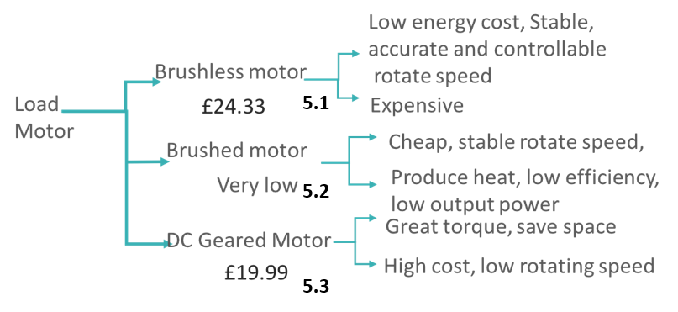

## Turning Mechanism - Paul Longe

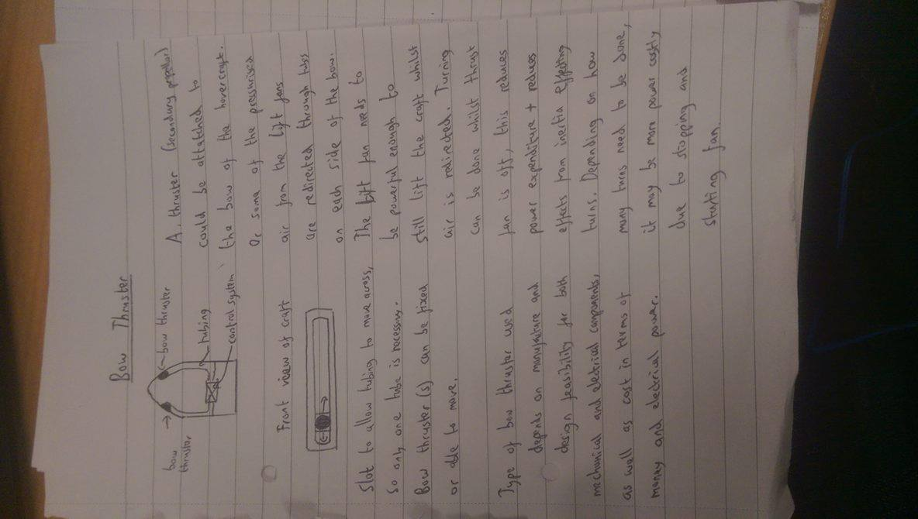**Bow Thrusters (Reference to synthesis Chart 1.1)**One concept was to use bow thrusters to control the craft, the basic idea is to have some of the air from the lift fan redirected through the sides of the craft so as to cause a change in direction through the principle of conservation of momentum. The lift fan needs to be powerful enough to still lift the craft while air is redirected. But a benefit of this idea is that the thrust fan can be turned off whilst the turns are made which will save on power, and reduce the effects caused by moment of inertia which allows the craft to have a smaller radius of turn.

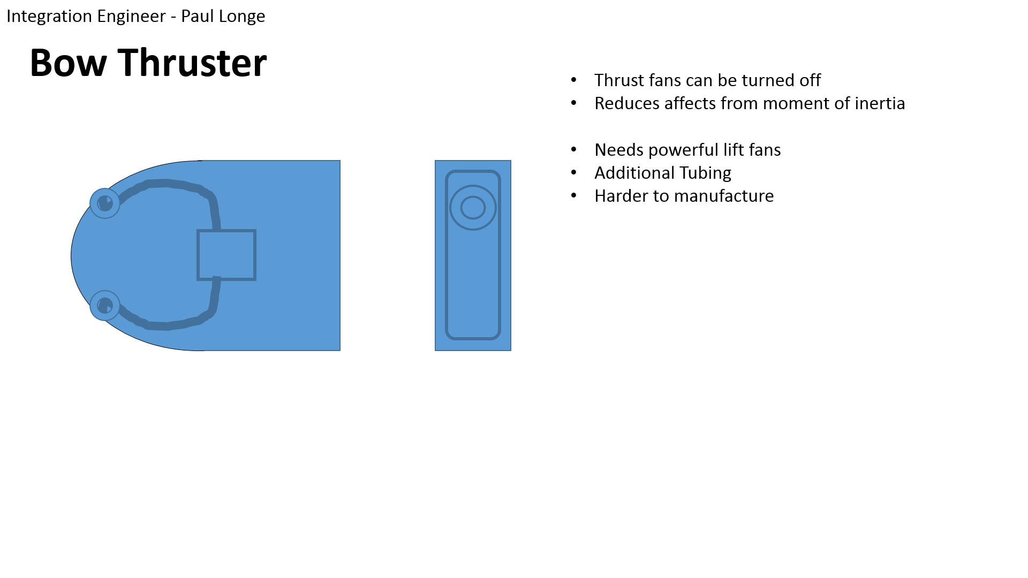

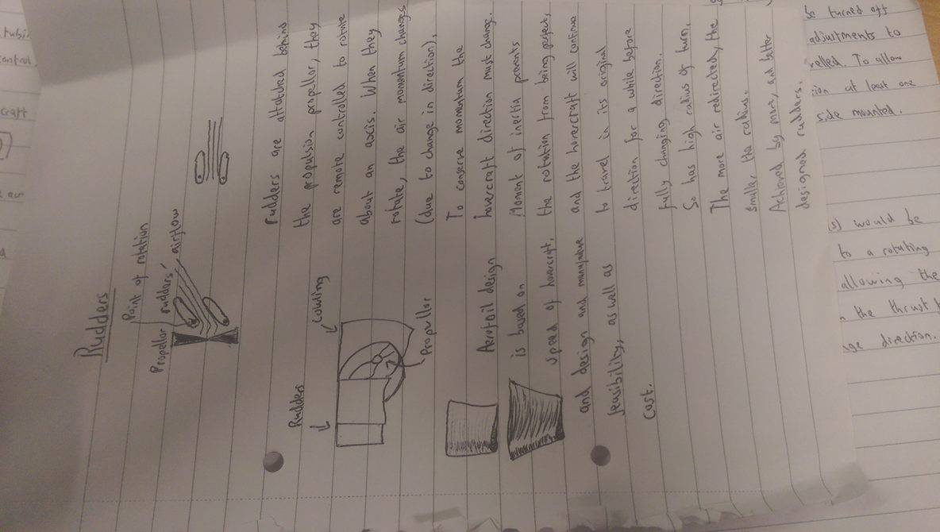**Rudders (Reference to synthesis Chart 1.2)**Another concept was to use rudders to redirect airflow from the thrust fan to control its direction. This would be easier to manufacture and can be freely designed to improve the quality.

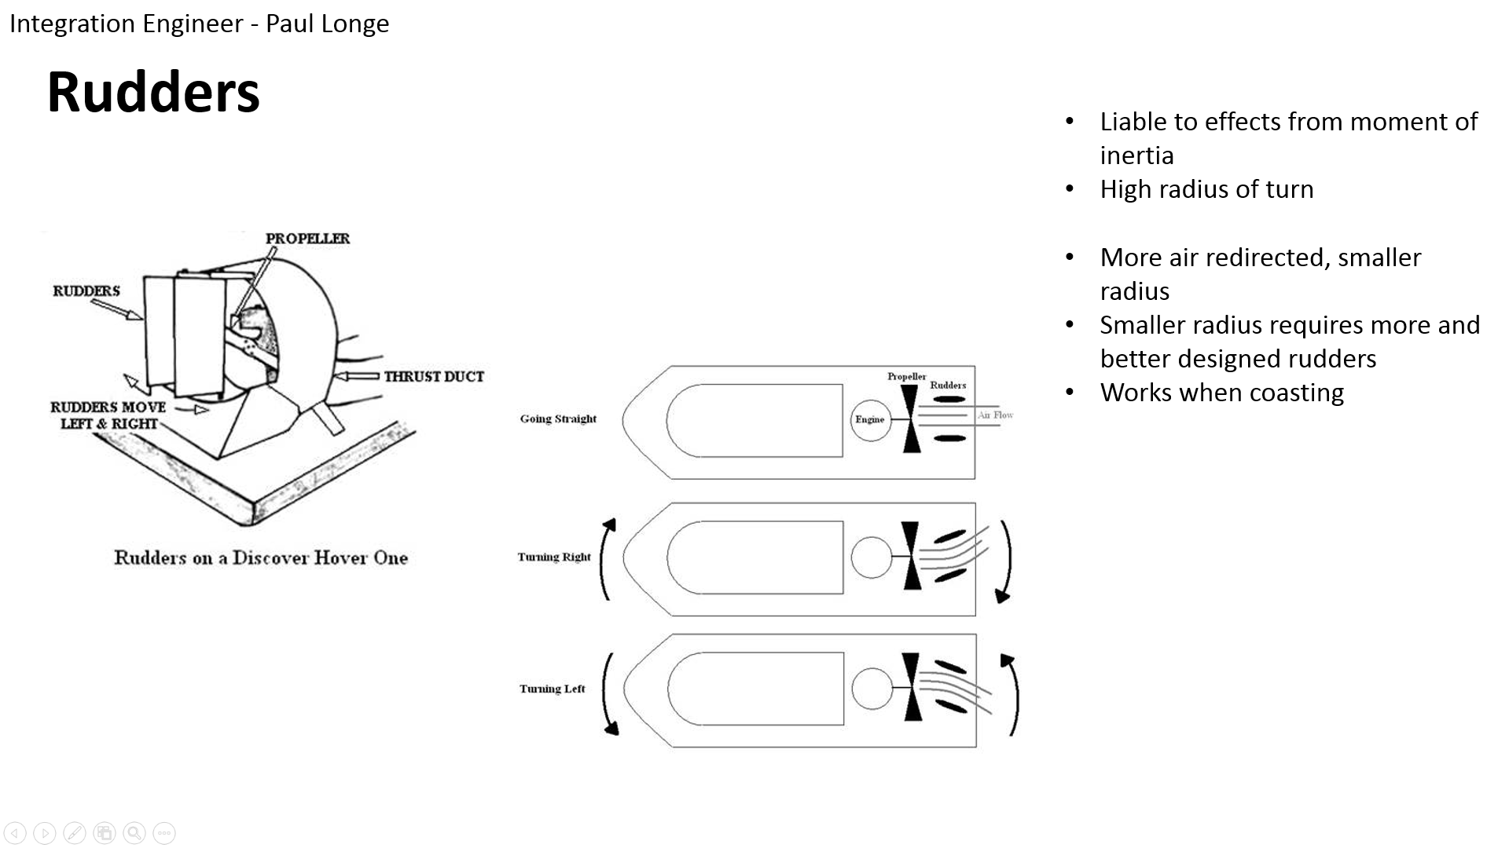

Images found online

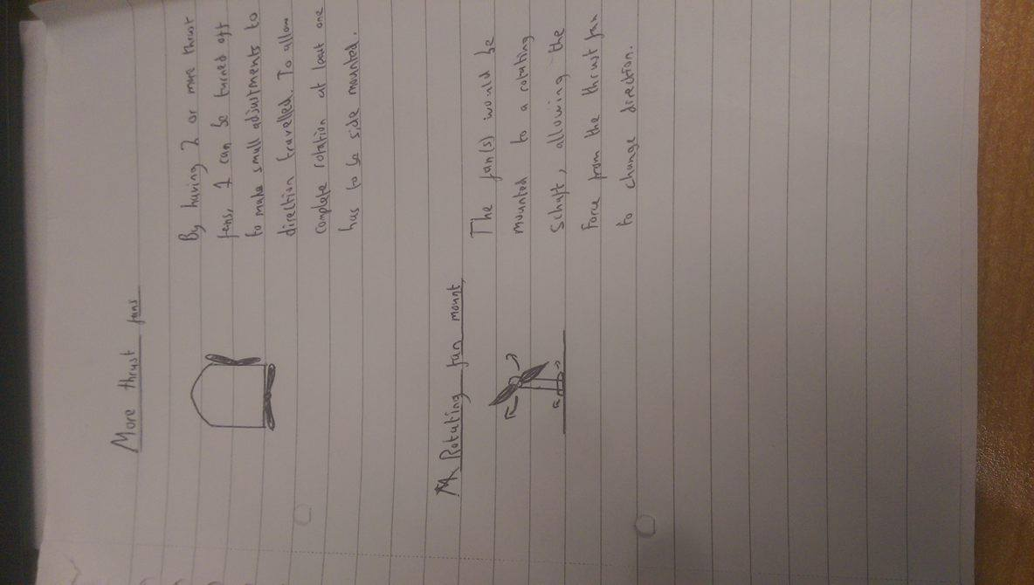

**Additional Thrust Fans (Reference to synthesis Chart 1.3)**

A concept was to use multiple thrust fans thrust fans which allows for several different designs as shown, but may be more expensive in terms of both cost and electrical power. The last concept was the use of a rotating fan, which is more complex to design but allows the hovercraft to stop even if the thrust fan cannot reverse direction.

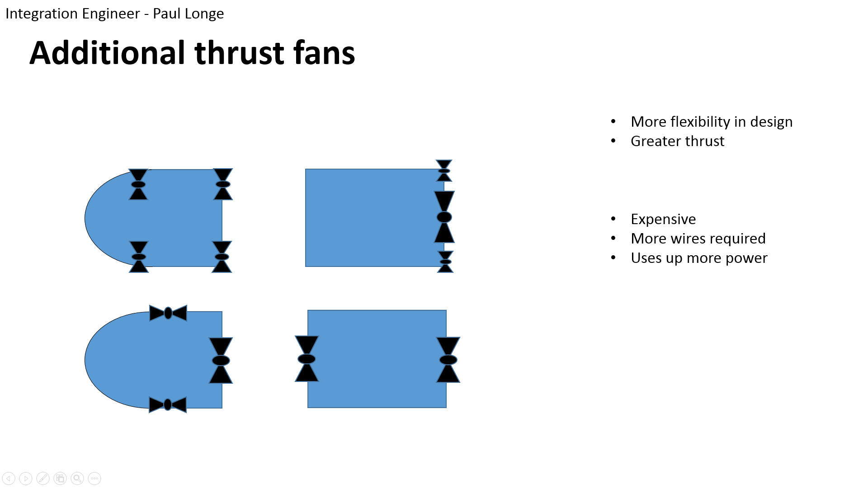**Rotating Thrust Fans (Reference to synthesis Chart 1.4)**

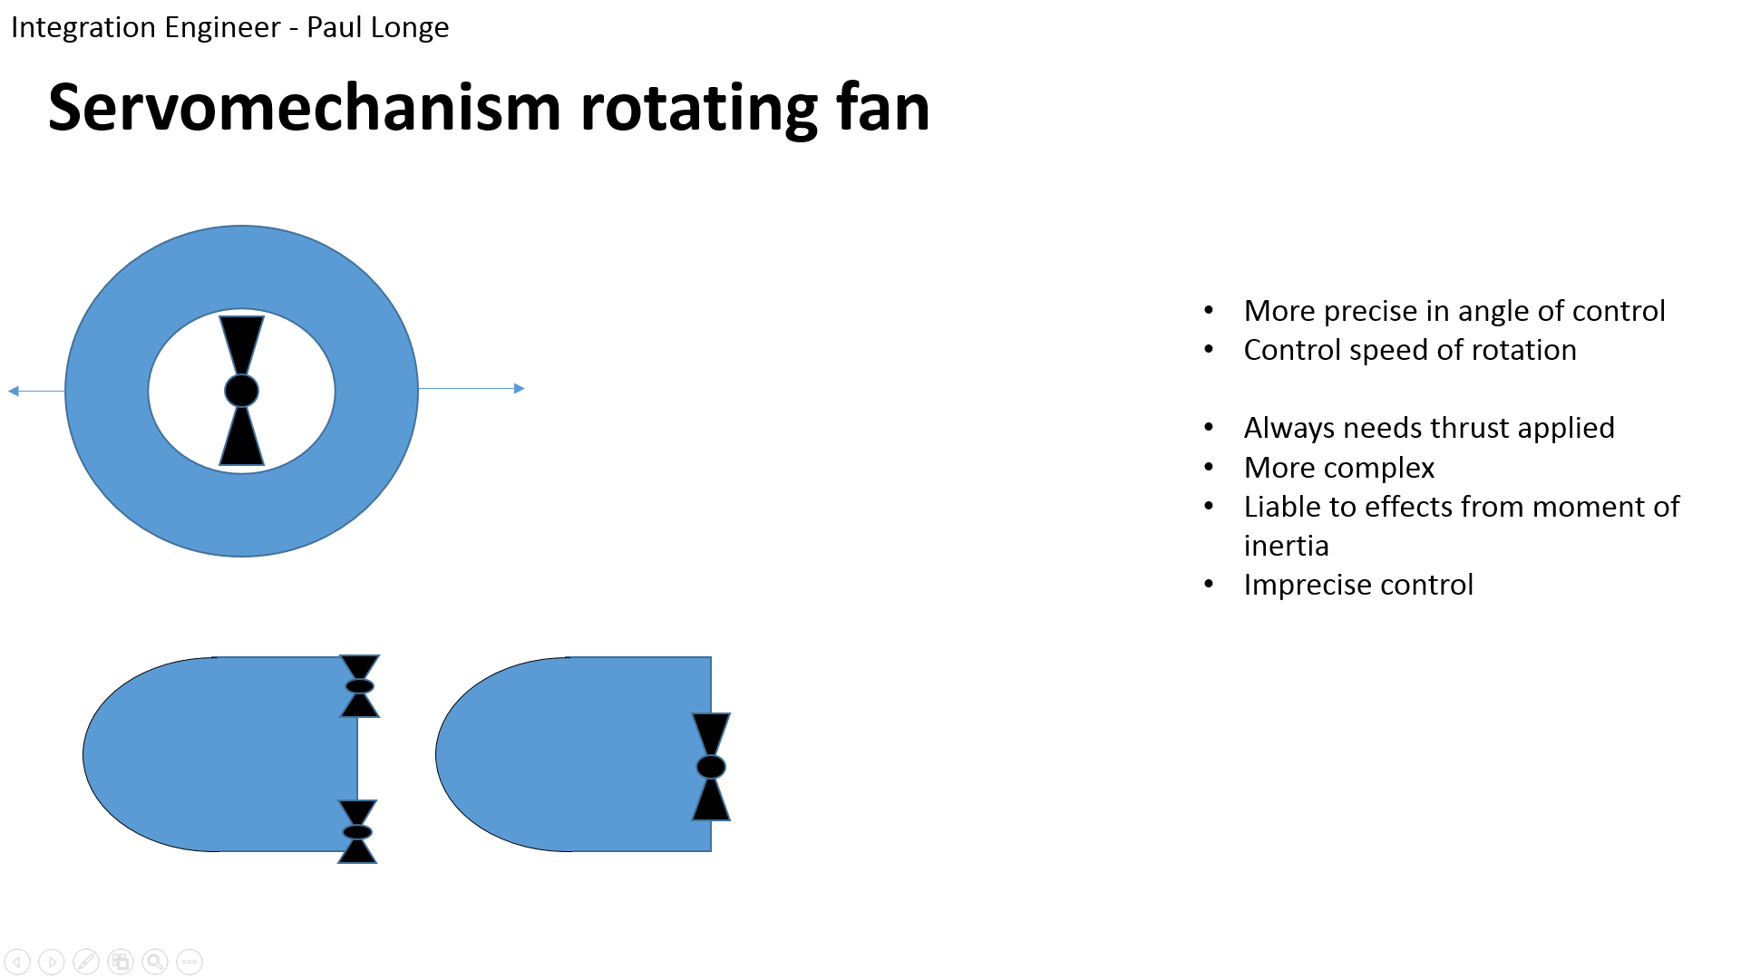

## Electrical Systems – Divine Abraham

At VDP1 there was an option to use either an electronic speed control (ESC’s) **(Reference to synthesis Chart 2.1)** or a Dual DC motor driver board. **(Reference to synthesis Chart 2.2)** The Dual DC motor driver board is cheaper and can control more fans than a single ESC. However, after much research and feedback from the design professor it was decided that it would be a better idea to use the ESC’s over the latter as it was cost efficient, easy to work with and requires no additional components for a functioning system.   
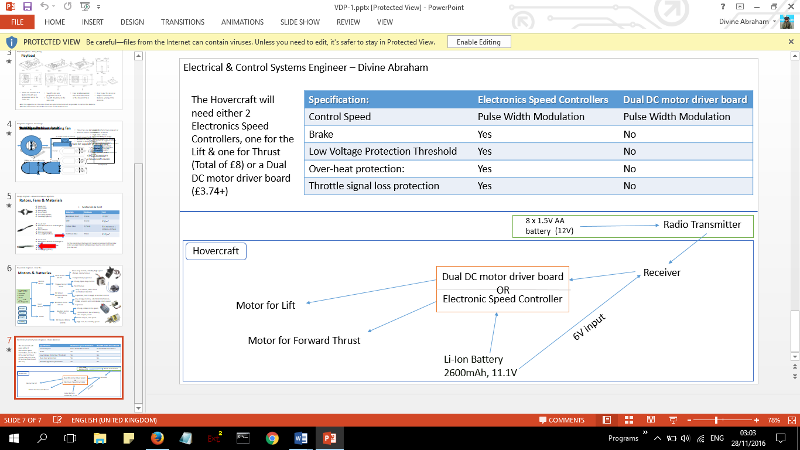

## Payload – Xiang Zhang

In the VDP 1, we made three hypotheses about the payload area.

In the first hypothesis, there are one propulsion fan and one lift fan. The lift fan is located on the front part and the propulsion fan is located on the pack part of the hovercraft. The load area is on a small table, which is placed above the lift fan. The position of a battery is between the lift and the propulsion fan.

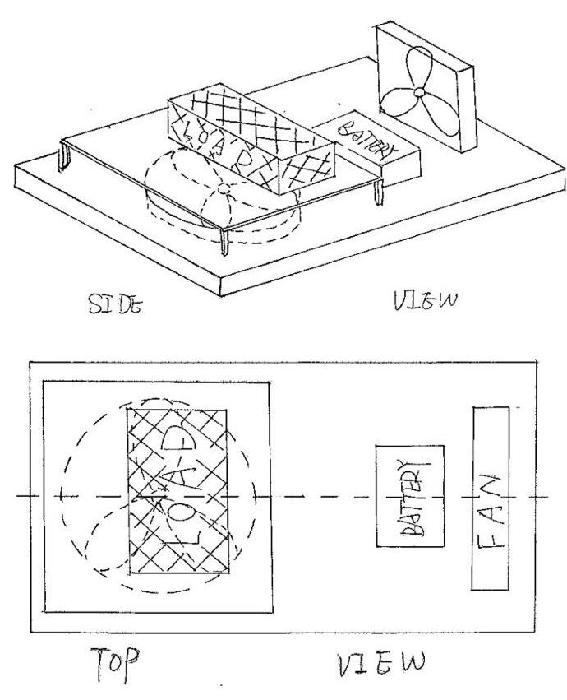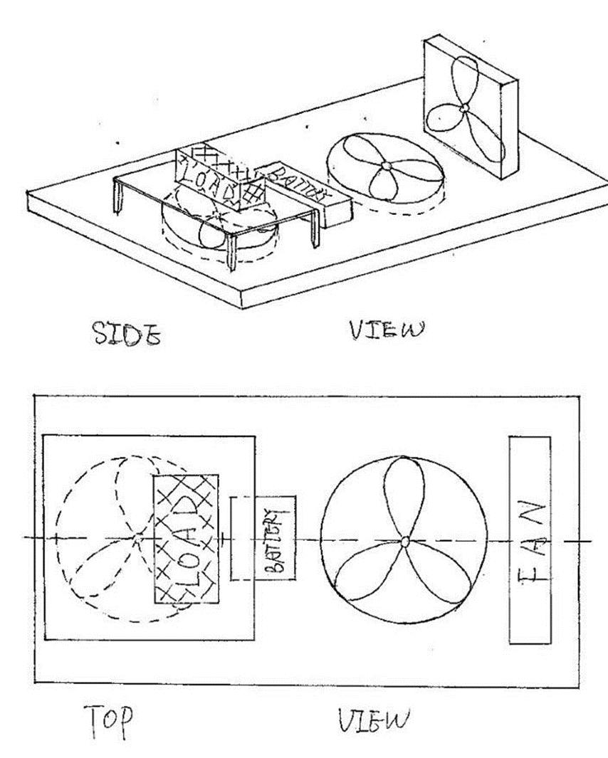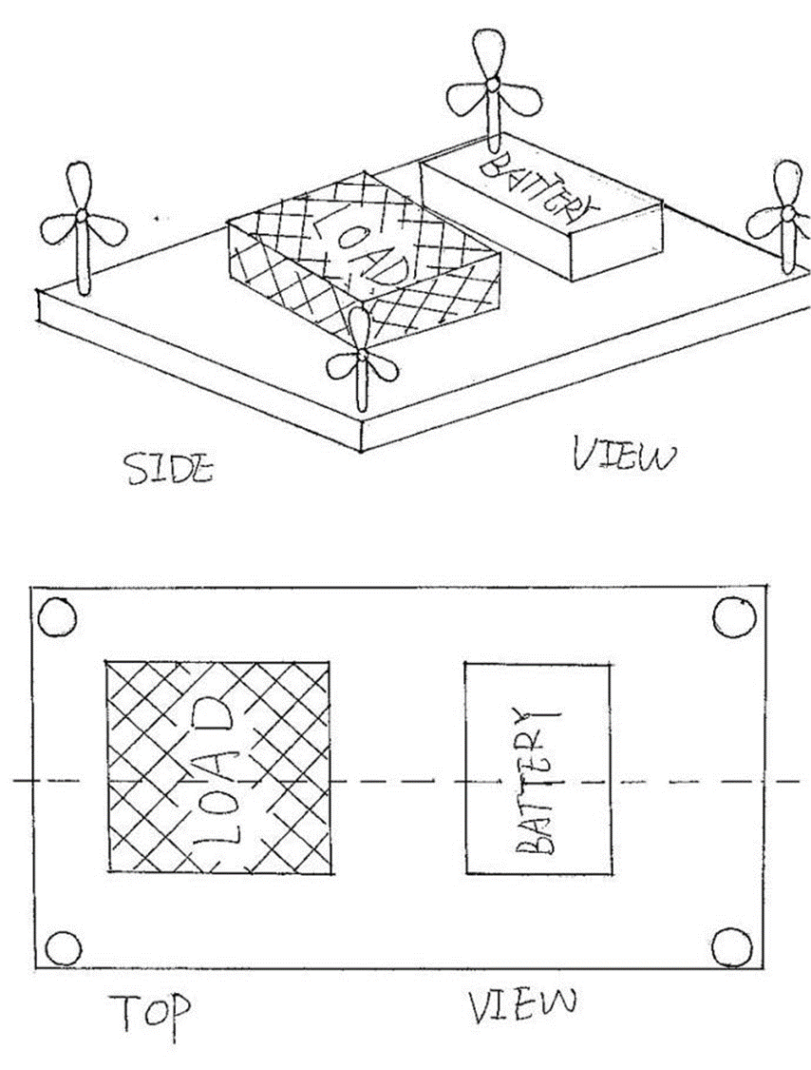

**3.1 3.2 3.3**

**Numbers as referenced in synthesis chart**

In the second one, we designed two lift fans and one propulsion fan. The prolusion fan is in the back part, one of the lift fan is just in front of the back fan the other one is in the upper part. This hypothesis is very similar to the first hypothesis; one more lift is used to help to control the balance.

The last one has four small propulsion fans placed in every corner of the payload area and one lift fan in the front. The load area is just above the lift fan and the battery placed behind it.

Around these three, we chose the second hypothesis. Because the two lift fans can provide more power than the other two. They can help the control the balance by changing the place of the lift fan as well. In addition, all of the apparatus in this area should be symmetrical as much as possible to control the balance.

Dimensions are shown below:

|  |  |  |
| --- | --- | --- |
| Name | Length x width x thickness/mm | Weight/g |
| Payload area | 415 x 292 x 25 | 340(without load) |
| Battery | 74 x 55 x 20 | 145 |

|  |  |  |
| --- | --- | --- |
| VDP1 | Goes to… | VDP2 |
| 2 lift fans | **1 lift fan** |
| 1 load area | **3 load areas** |
| Load area above the lift fan | **Load area around battery** |
| Cowling is a circle | **Cowling is a square** |
| No support for motor | **Motor holder provided** |

# Synthesis chart

|  |  |  |  |  |  |  |  |  |  |  |  |  |  |  |  |  |  |  |  |  |  |  |  |  |  |
| --- | --- | --- | --- | --- | --- | --- | --- | --- | --- | --- | --- | --- | --- | --- | --- | --- | --- | --- | --- | --- | --- | --- | --- | --- | --- |
| **Criteria +weight** | **Concept Score /10** | | | | | | | | | | | | | | | | | | | | | | | | |
|  | **1.1** | **1.2** | **1.3** | **1.4** | **2.1** | **2.2** | **3.1** | **3.2** | **3.3** | **4.11** | **4.12** | **4.13** | **4.2** | **4.31** | **4.32** | **4.4** | **5.1** | **5.2** | **5.3** | **5.4** | **5.5** | **5.6** | **6.1** | **6.2** | **6.3** |
| Cost x0.4 | 3 | 10 | 2 | 2 | 7 | 3 | 3 | 4 | 5 | 5 | 5 | 5 | 4 | 4 | 7 | 5 | 7 | 8 | 3 | 3 | 10 | 3 | 2 | 4 | 2 |
| Feasibility x0.8 | 4 | 10 | 10 | 4 | 5 | 8 | 3 | 6 | 4 | 6 | 7 | 5 | 5 | 3 | 7 | 7 | 8 | 6 | 4 | 8 | 8 | 3 | 3 | 5 | 6 |
| Ability to overcome obstacles x0.8 | -2 | x | X | X | 9 | 1 | 5 | 8 | 4 | 5 | 5 | 5 | 7 | 8 | 6 | 8 | x | x | x | 7 | 6 | 5 | 8 | 8 | 8 |
| Production time x0.5 | 2 | 5 | 5 | 4 | 2 | 2 | 4 | 6 | 4 | 6 | 8 | 5 | 5 | 4 | 7 | 4 | x | x | x | x | x | x | 6 | 5 | 7 |
| Energy cost x0.5 | 2 | 10 | 2 | 2 | 7 | 3 | 5 | 7 | 6 | 5 | 5 | 6 | 4 | 7 | 6 | 6 | 7 | 8 | 8 | 8 | 5 | 6 | 6 | 4 | 2 |
| Manoeuvrability x0.2 | 8 | 3 | 5 | 3 | 6 | 0 | 5 | 5 | 7 | 6 | 6 | 4 | x | 7 | 6 | 7 | 8 | 7 | 6 | x | x | x | 4 | 6 | 8 |
| Safety x0.4 | X | X | X | X | 2 | 2 | x | x | x | x | x | x | 7 | x | x | x | x | x | x | x | x | x | 6 | 6 | 6 |
| Payload Capacity x0.5 | X | X | X | X | 5 | x | 6 | 4 | 7 | x | x | x | 7 | 7 | 6 | 7 | x | x | X | x | x | x | 2 | 2 | 2 |
| Start Stop Capability x1 | 0 | 0 | 6 | 0 | 4 | 8 | x | x | x | x | x | x | x | x | x | x | 8 | 7 | 7 | 7 | 7 | 7 | 7 | 6 | 8 |
| Total Score | 17 | 38 | 30 | 15 | 47 | 27 | 31 | 40 | 37 | 33 | 36 | 30 | 39 | 40 | 45 | 44 | 38 | 36 | 28 | 33 | 36 | 24 | 44 | 46 | 49 |
| Weighted score | 6.4 | 20.1 | 19.3 | 7.6 | 27 | 19.7 | 16.1 | 22.3 | 18.3 | 17.5 | 19.3 | 16.3 | 22 | 20.8 | 23.9 | 23.9 | 22.3 | 20.4 | 16.6 | 24.2 | 24.7 | 17.6 | 26.8 | 27.1 | 29.5 |

# Materials & Pricing - Alexandros Agrafiotis

A model hovercraft in the dimensions of an A3 size and around 2kg with only 12V battery, in order to be lifted from a single centrifugal fan, a very light weight material should be found. This material should meet some requirements such as stiffness, light weight, low cost and easy to change the shape of it. After taking into account the materials provided from the university’s workshop and their prices we ended up with three different materials with completely different properties from each other. The first one was the aluminium sheet, a 0.9mm thickness and a cost of £11/m2. Second material was the MDF with a 3.6mm thickness and only £3/m2. The last material was the craft foam blue, a very light material compared to the other two and with a great stiffness for our application. Also, a material that it is significantly easy to modify in the workshop and with a price of £12/m2. So, the craft foam blue was meeting all our specifications and it was the most suitable material for what we were planning to apply it to. However, some parts of the hovercraft are not going to be made from craft foam blue such as the safety cover from the fans. For these application the most common materials that we will use are going to be metals, likely aluminium and MDF. Around 80% of the materials is going to be the craft foam blue.

|  |  |  |
| --- | --- | --- |
| Cost of Materials and Components | | |
| Material / Component | Number of items | Price (£) |
| Centrifugal Fan | 1 | 10.60 |
| Blades | 2 | 6.80 |
| Motor | 2 | 8 |
| Plastic bag | 1 | 1 |
| Craft Foam Blue | 1 | 12 |
| 6 Channel Radio | 1 | 30 |
| Battery-Charger | 1 | 60 |
| Electronic Speed Controller | 4 | 16 |
| Metal (small parts) | 1 | 10 |
| Servo | 1 | 6.67 |
| Wires | 1 | 4.08 |
| Other Materials | - | 20 |
| Total | 13 | £185.15 |

# Conclusion on design After VDP2 – Xiang Zhang

## Chassis – Bradley Blocksidge

**VDP 2 Section.**

For our second meeting we had to have completed a prototype concept design for our model hovercraft. The chassis and skirt for the hovercraft now have a final design of how they are going to look and how they will work.

The final decided shape of the body is a rounded rectangle shape. This shape was chosen because of its simplicity to create and also how easy the skirt will be able to attach to the body. In a model our size a streamline shape isn’t necessary as it will only have a slight effect, because of this the simplicity is the most important decision when a shape was chosen.

The reinforcement layer continued to stay in our minds when creating our hovercraft designs. From further research into the field a hovercraft of our size (415 x 292mm) one piece of the craft foam blue wouldn’t be able to hold the 2kg maximum mass hovercraft that we based our calculations on. Due to this a reinforcement layer of MDF will be used. This reinforcement layer doesn’t have a set size currently. This is down to use not knowing how the top layer will react under the stresses and that we need to use as little amount of MDF as possible to give the hovercraft a smaller mass.

The momentum curtain was a certainty for our design from the start. This will also be made of MDF as it is thin and strong. By having the momentum curtain you can give the hovercraft extra lift. There is no reason to not have this momentum curtain, it can easily be attached with 4 pins and shouldn’t add much weight to the hovercraft. The MDF for this piece will be almost as big as the top shaped layer to increase the velocity of the air as much as possible.

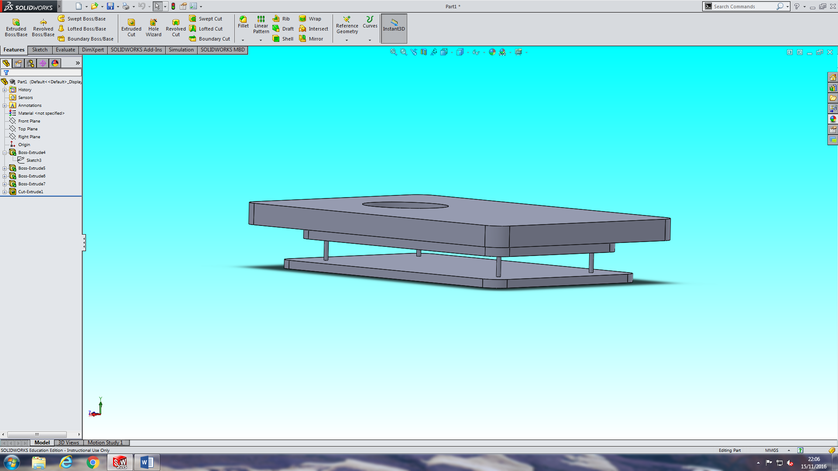

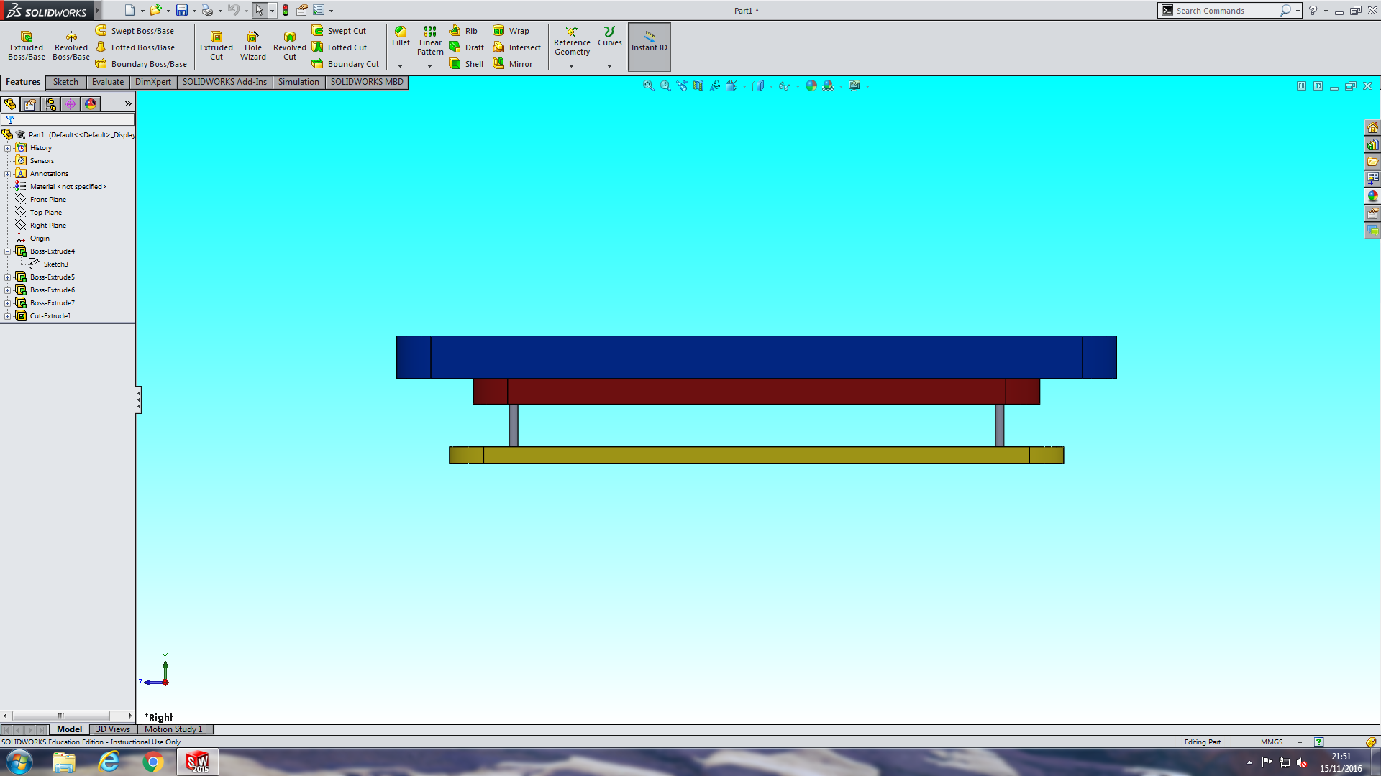

Finally the skirt had to be considered. A wall design ended up being our final decision. The wall design is very simple and will be very easy to attach to the hovercraft. One flaw in the wall design is that a lot of air will leak when going over objects. To combat this we have a momentum curtain and a very powerful blower so when the air is leaked the pressure in the skirt stays high.

## Fans and Materials selection - Alexandros Agrafiotis

Based on VDP’s 2 feedback, we are going to change the size of the hole in the hovercraft in order to increase the airflow without affecting the centrifugal fan’s ascription. In terms of materials, craft foam blue is going to be used with some extra metals for the safety covers. The amount we will spend is going to stay the same. All in all, nothing else is going to change as there were no issues. The final design is as follows below:

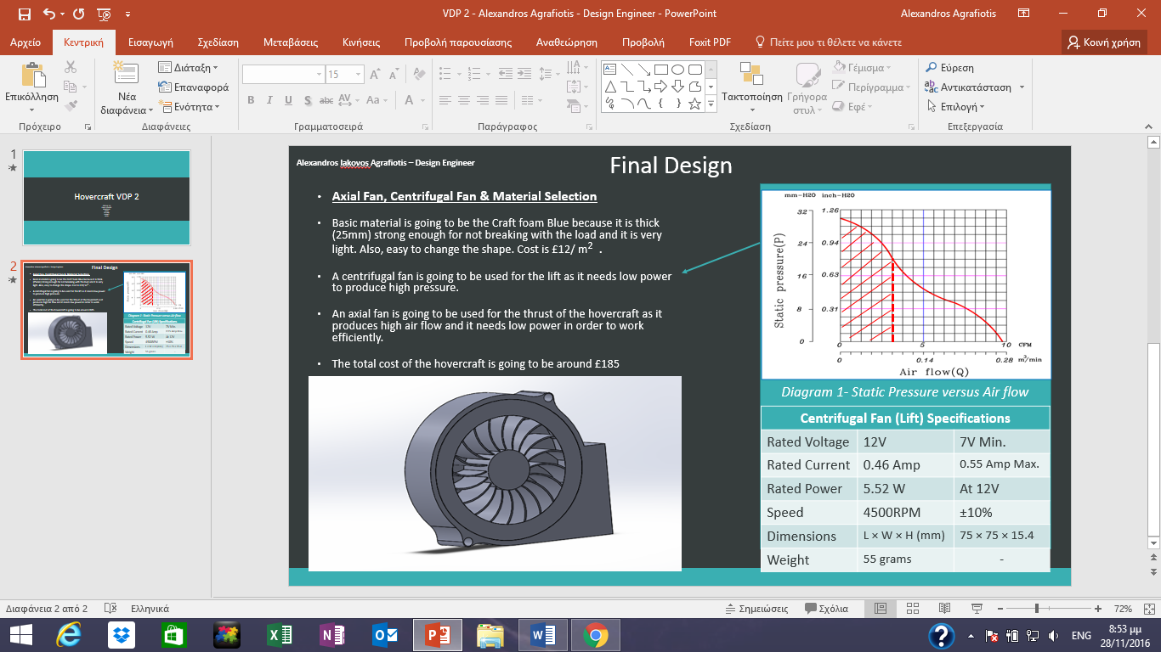

## Powertrain system – Keqi Shu

According to the VDP2’s feedback, I have taken serious consideration on the thrust motor and decided to use the motor with an adapted voltage of 6-15V, which fits our battery perfectly and it can also rotate reversely which will greatly help our speed controlling through the process when the hovercraft is turning around. As we are using a big motor, we will be using smaller blades. Hans the other smaller motors all had a working voltage of 3V which will have the same energy cost with some difficulties in adjusting the voltages. The lift fan will be a blower, which is quite efficient and saves a lot of energy.

The circuit will be a parallel circuit shown below, it will provide the whole system with exact amount of power needed and also will have a guarantee of safety. The servo will be use with a resister as it has lower voltage demands. And there is also an inverse chip to inverse the motion of the lift fan to make the hovercraft speed to be more controllable.

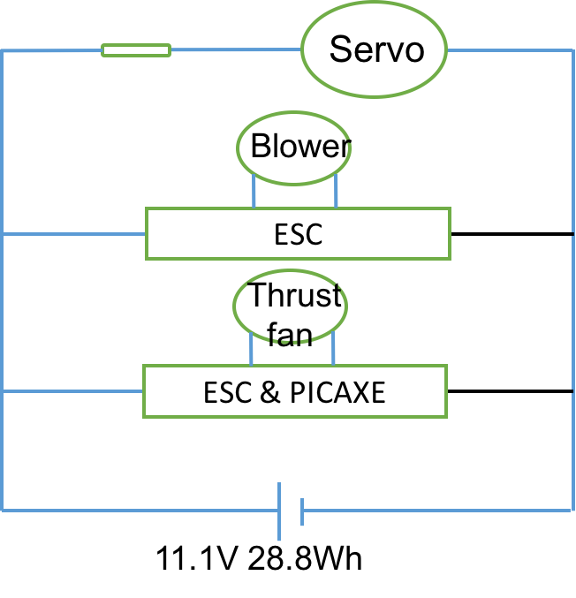

For the rudder structure we are using a four bar linkage as shown below, I used the law of sin and the law of cos to figure out the relationship between the turning angle of the servo and the rudder. This method will help to get a precise turning degree of rudder considered to the turning angle of the servo when we actually started manufacture the hovercraft. I put more turning angles on one side because we only need to turn from one direction, and put less turning angles to the other side just enough to keep the hovercraft going straight.

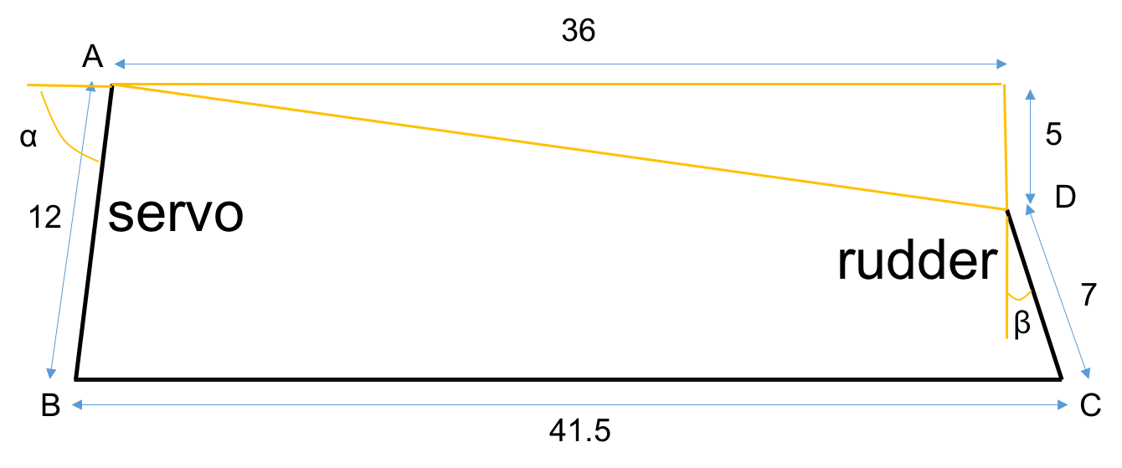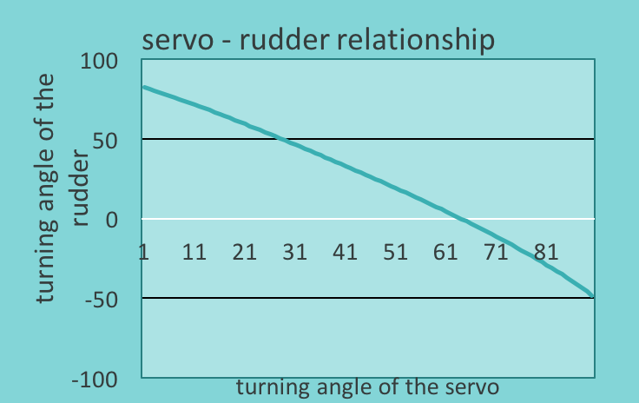

## Turning Mechanism – Paul Longe

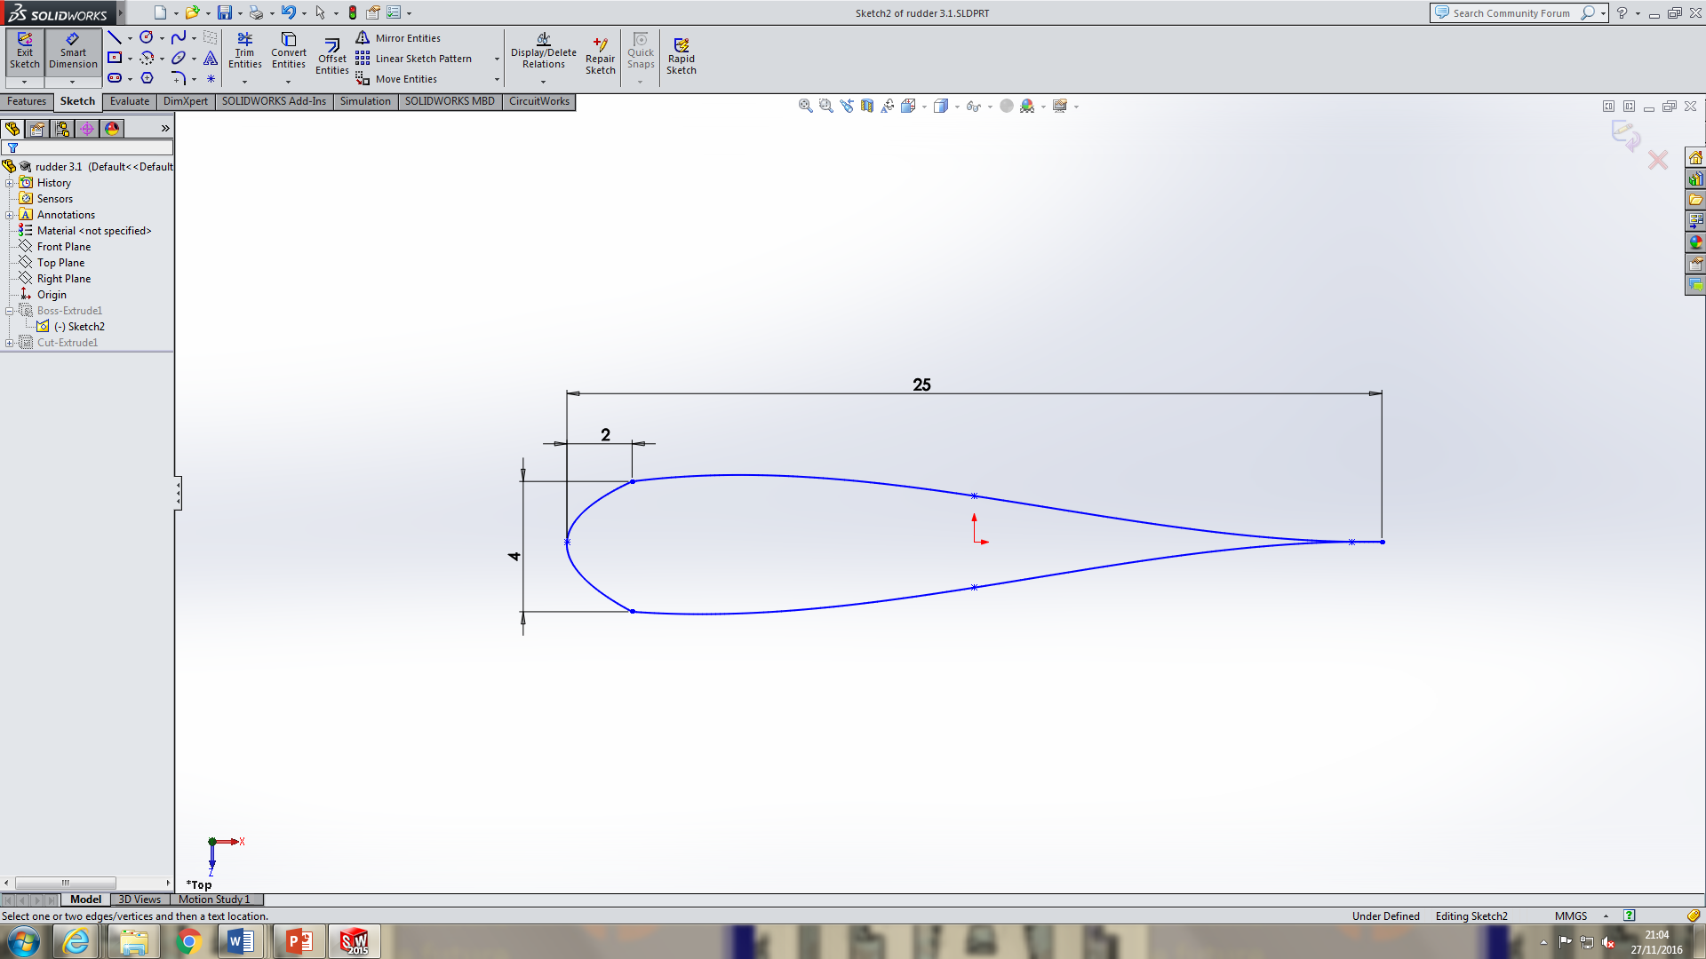Following VDP2 a final design was chosen. It was decided after reviewing the design specification that rudders were the best option as they are easy and cheap to manufacture, require little electrical power to control, and as the fans have a reverse setting the hovercraft is still able to stop as required. The final concept design has dimensions as shown, in a symmetrical aerofoil shape to redirect the most airflow possible. The rudders has a depth of 100mm so it covers the whole of the fan area and more airflow can be redirected, the rudder is secured by a pin so it can attach to the cowling and the pin is located in the thickest part where it can bear the most load. Two rudders are to be used because the more rudders there are the greater amount of airflow can be redirected, and by only having two rudders, a large amount of air can be redirected.

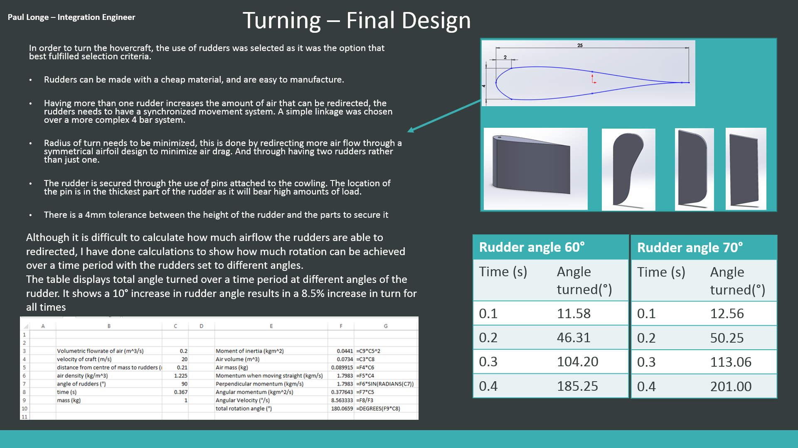

## Electrical Control – Divine Abraham

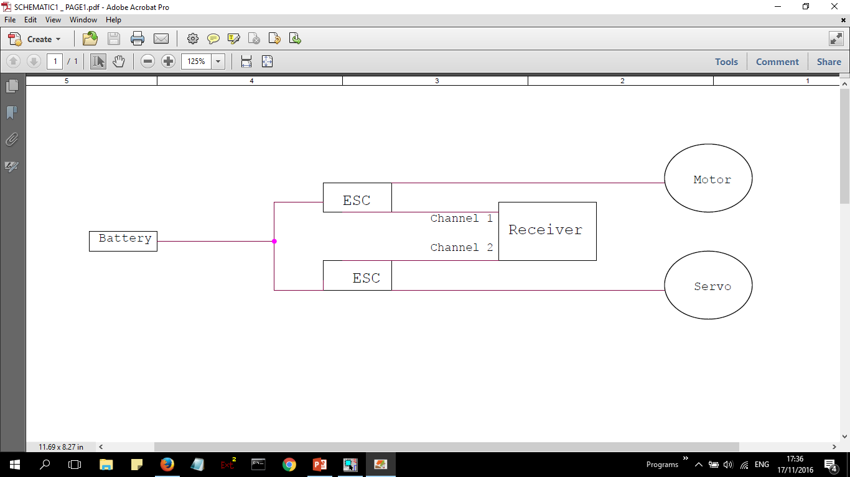Following on from the feedback received from VDP2, It was concluded that an additional circuit be mandatory which will be used to drive the fans in the opposite direction and get the hovercraft to reverse. The rechargeable battery will be directly connected to the electronic speed controllers (ESC’s) using the positive and negative terminals. There is an intention to use a connector block to connect the nodes to multiple ESC’s. A connection to the motors will be made from the ESC’s and the correct voltage for the motors and the receiver, which has a 3-pin connection to the ESC, will dictate servo.

OrCAD illustration of the finished circuit

## Payload - Xiang Zhang

The graph below is the final design the payload area.

In order to control the balance of the hovercraft, nearly all the components should be placed symmetrically about the vertical centre line.

There are grooves on the payload area that are used to position the components into the right place. The grooves help to fix the components and save area. Saved area means the total weight will be reduced as well, so we can put more load on the hovercraft. At the same time, all of the grooves should be a little larger than the actual dimension of the components. Because the dimension we found from the website may have errors, 1-2mm larger will help to fix them easier.

The lift fan is placed in the front part; the shallow hole is a little larger than the actual size and the deep hole is the same size as the data we found from website, the blower will be fixed with the hole perfectly to blow air to the chassis.

The propulsion fan is placed in the back part. The cowling is designed into square because square is more stable than circle. Four small sticks are stick at the back of the cowling. They are used to fix the rudders. Servo area is just beside the cowling, because the servo is only 11g, I want to reduce the distance between the centre line and the servo as much as possible. It can be balance when we put the electrical components on as well. The motor holder is located in front of the cowling. The cylinder area fixes the motor, and the centre of the cylinder is the same height as the centre of the propulsion fan. Therefore, the motor can connect the propulsion fan perfectly. Of course there is a groove under the holder to fit it.

Because of the weight in front and back part are different (shown in the table below), the position area is used to control the balance. Horizontally symmetric---left hand side moment=right hand side moment

*When use two load area:* (150+11+51) x (87.5+15) = 33 x 102.5+200 x X+200 x X(X=position of the load)

X=46 mm

*After change the load area to three part:* 157.5 x 180 + (51+10) x 122 + 48 x 145 = 33 x 92 +200 x 20 x 2 + 200 x X(X=position of the load)

X =159 mm

Two of them should be placed 20mm away and the other one should be placed 159mm away from the centreline.

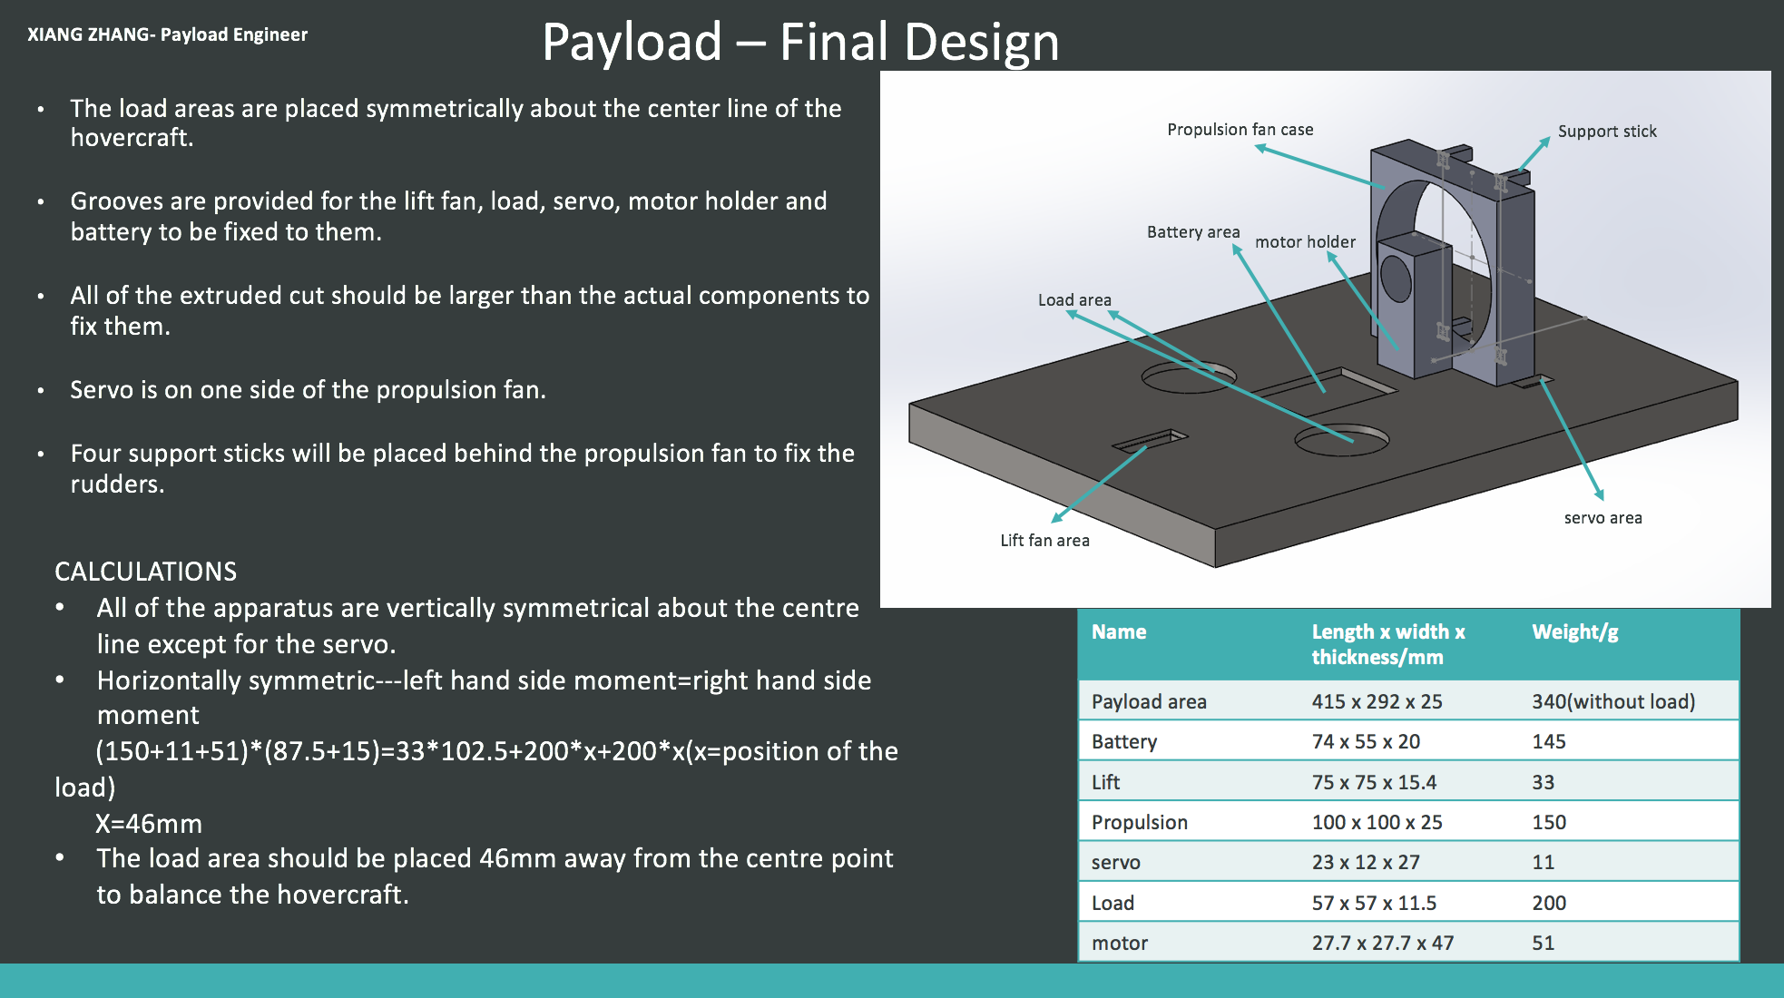

Using the feedback from the VDP meetings, we have updated and improved our model to improve the designs. The hovercraft as a whole need to lie within the specification. The body cannot be larger than 420 x 297mm, but still needs to have the skirt. We want the payload area to be light as possible to reduce the total weight so we can have a larger load. The final design of the rudders should be in a symmetrical aerofoil shape to redirect the most airflow possible. When we chose the materials, we tried to find a light, strong and cheap one, which can be easily changed to suit our needs. For the lift blower, it needs to produce high pressure whilst only using a low amount of power. When deciding a servo, we want it to be cheap, light and closed loop. This helps to give accurate control and a high torque servo. The control system should get enough lift and be capable of overcoming small obstacles.

# Appendix

Link to hovercraft turning picture

http://www.discoverhover.org/infoinstructors/newguides/guide13-turning.htm